**Shamil Yakupov  
SE-2218  
Food delivery application**

**Intro_screen.dart:**

import 'package:flutter/material.dart';

import 'home_page.dart';

class IntroScreen extends StatelessWidget {

  const IntroScreen({super.key});

  @override

  Widget build(BuildContext context) {

    return Scaffold(

      backgroundColor: Colors.grey[50],

      body: SafeArea(

        child: Column(

          children: [

            // big logo

            Padding(

              padding: const EdgeInsets.only(

                left: 100.0,

                right: 100.0,

                top: 120,

                bottom: 20,

              ),

              child: Image.asset('lib/images/avocado.png'),

            ),

            // we deliver groceries at your doorstep

            const Padding(

              padding: EdgeInsets.all(28.0),

              child: Text(

                'We deliver groceries at your doorstep',

                textAlign: TextAlign.center,

              ),

            ),

            // groceree gives you fresh vegetables and fruits

            Text(

              'Fresh items everyday',

              textAlign: TextAlign.center,

              style: TextStyle(

                fontSize: 16,

                color: Colors.grey[700],

              ),

            ),

            const SizedBox(height: 24),

            const Spacer(),

            // get started button

            GestureDetector(

              onTap: () => Navigator.pushReplacement(

                context,

                MaterialPageRoute(

                  builder: (context) {

                    return const HomePage();

                  },

                ),

              ),

              child: Container(

                padding: const EdgeInsets.all(24),

                decoration: BoxDecoration(

                  borderRadius: BorderRadius.circular(16),

                  color: const Color.fromARGB(255, 112, 91, 222),

                ),

                child: const Text(

                  "Get Started",

                  style: TextStyle(

                    color: Colors.white,

                    // fontWeight: FontWeight.bold,

                    fontSize: 16,

                  ),

                ),

              ),

            ),

            const Spacer(),

          ],

        ),

      ),

    );

  }

}

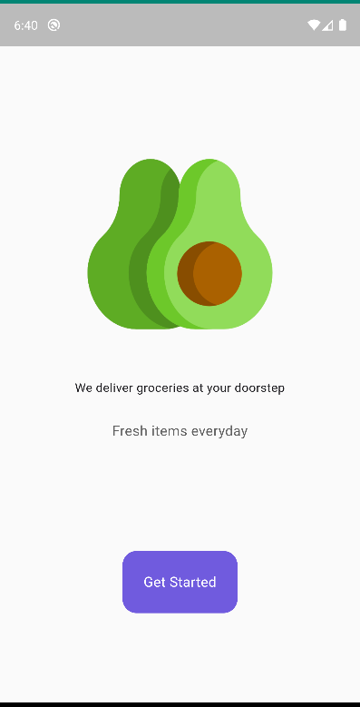

**This Flutter code defines a `IntroScreen` widget, which represents the introductory screen of a grocery delivery app. Let's break down its structure and functionality:**

**1. **Widget Structure**:**

- The `IntroScreen` widget is a stateless widget (`StatelessWidget`) that displays the introductory content of the app.

- It is composed primarily of a `Scaffold` widget, providing a basic structure for the screen.

**2. **Content**:**

- The background color of the screen is set to a light shade of grey (`Colors.grey[50]`).

- Inside the `SafeArea`, there is a column (`Column`) widget containing various components stacked vertically**.**

**3. **Components**:**

- A large logo (presumably representing the app) displayed using an `Image.asset` widget.

- A text widget displaying the message "We deliver groceries at your doorstep".

- Another text widget displaying the message "Fresh items everyday" with a smaller font size and grey color.

- A "Get Started" button wrapped in a `GestureDetector` widget. When tapped, it navigates to the `HomePage`.

**4. **Styling**:**

- The styling of the "Get Started" button includes a purple background color with rounded corners and white text.

**5. **Navigation**:**

- The "Get Started" button is configured with a `GestureDetector` that triggers a navigation event to replace the current screen with the `HomePage` when tapped**.**

**Homr_page.dart:**

import 'package:flutter/material.dart';

import 'package:google_fonts/google_fonts.dart';

import 'package:provider/provider.dart';

import '../components/grocery_item_tile.dart';

import '../model/cart_model.dart';

import 'cart_page.dart';

class HomePage extends StatefulWidget {

  const HomePage({Key? key}) : super(key: key);

  @override

  State<HomePage> createState() => _HomePageState();

}

class _HomePageState extends State<HomePage> {

  @override

  Widget build(BuildContext context) {

    return Scaffold(

      appBar: AppBar(

        backgroundColor: Colors.transparent,

        elevation: 0,

        leading: Padding(

          padding: const EdgeInsets.only(left: 24.0),

          child: Icon(

            Icons.location_on,

            color: Colors.grey[700],

          ),

        ),

        title: Text(

          'Astana, Kazakhstan',

          style: TextStyle(

            fontSize: 16,

            color: Colors.grey[700],

          ),

        ),

        centerTitle: false,

        actions: [

          Padding(

            padding: const EdgeInsets.only(right: 24.0),

            child: Container(

              padding: const EdgeInsets.all(16),

              decoration: BoxDecoration(

                color: Colors.grey[200],

                borderRadius: BorderRadius.circular(12),

              ),

              child: const Icon(

                Icons.person,

                color: Colors.grey,

              ),

            ),

          ),

        ],

      ),

      floatingActionButton: FloatingActionButton(

        backgroundColor: Colors.black,

        onPressed: () => Navigator.push(

          context,

          MaterialPageRoute(

            builder: (context) {

              return const CartPage();

            },

          ),

        ),

        child: const Icon(Icons.shopping_bag),

      ),

      body: SingleChildScrollView(

        child: Column(

          crossAxisAlignment: CrossAxisAlignment.start,

          children: [

            const SizedBox(height: 48),

            // good morning bro

            const Padding(

              padding: EdgeInsets.symmetric(horizontal: 24.0),

              child: Text('Good morning,'),

            ),

            const SizedBox(height: 4),

            // Let's order fresh items for you

            Padding(

              padding: const EdgeInsets.symmetric(horizontal: 24.0),

              child: Text(

                "Let's order fresh items for you",

                style: GoogleFonts.notoSerif(

                  fontSize: 36,

                  fontWeight: FontWeight.bold,

                ),

              ),

            ),

            const SizedBox(height: 24),

            const Padding(

              padding: EdgeInsets.symmetric(horizontal: 24.0),

              child: Divider(),

            ),

            const SizedBox(height: 24),

            // categories -> horizontal listview

            Padding(

              padding: const EdgeInsets.symmetric(horizontal: 24.0),

              child: Text(

                "Fresh Items",

                style: GoogleFonts.notoSerif(

                  //fontWeight: FontWeight.bold,

                  fontSize: 18,

                ),

              ),

            ),

            // recent orders -> show last 3

            Consumer<CartModel>(

              builder: (context, value, child) {

                return GridView.builder(

                  shrinkWrap: true,

                  padding: const EdgeInsets.all(12),

                  physics: const NeverScrollableScrollPhysics(),

                  itemCount: value.shopItems.length,

                  gridDelegate: const SliverGridDelegateWithFixedCrossAxisCount(

                    crossAxisCount: 2,

                    childAspectRatio: 1 / 1.2,

                  ),

                  itemBuilder: (context, index) {

                    return GroceryItemTile(

                      itemName: value.shopItems[index][0],

                      itemPrice: value.shopItems[index][1],

                      imagePath: value.shopItems[index][2],

                      color: value.shopItems[index][3],

                      onPressed: () =>

                          Provider.of<CartModel>(context, listen: false)

                              .addItemToCart(index),

                    );

                  },

                );

              },

            ),

          ],

        ),

      ),

    );

  }

}

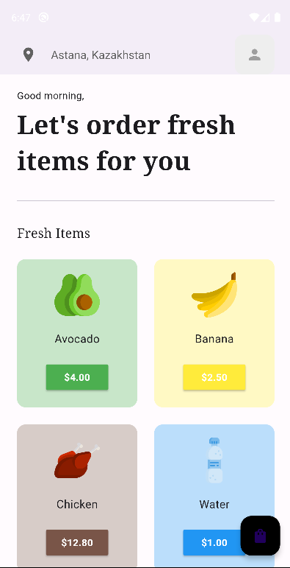

**This Flutter code defines a `HomePage` widget, which represents the main screen of a grocery delivery app. Let's break down its structure and functionality:**

**1. **Widget Structure**:**

- The `HomePage` widget is a stateful widget (`StatefulWidget`) that displays the main content of the app.

- It consists of a `Scaffold` widget, providing a basic layout structure for the screen.

**2. **App Bar**:**

- The app bar is configured with a transparent background and no elevation (`elevation: 0`).

- It contains the location icon on the left side and the user profile icon on the right side.

**3. **Floating Action Button**:**

**-** A floating action button (FAB) is placed at the bottom right corner, allowing users to navigate to the cart page (`CartPage`) when tapped.

- The FAB displays an icon representing a shopping bag (`Icons.shopping_bag`).

**4. **Body Content**:**

**-** The body of the `HomePage` consists of a `SingleChildScrollView` containing various components stacked vertically.

- It starts with some padding (`SizedBox(height: 48)`) followed by a greeting text ("Good morning,") and a title ("Let's order fresh items for you").

- A divider separates the greeting/title section from the rest of the content.

**5. **Categories and Recent Orders**:**

- The "Fresh Items" heading is displayed above a grid view (`GridView.builder`) showing fresh items available for purchase.

- The `GridView.builder` dynamically generates `GroceryItemTile` widgets for each item in the cart model.

- Each `GroceryItemTile` represents a grocery item with its name, price, image, and color. Tapping on a tile adds the item to the cart.

**6. **Provider**:**

- The `Consumer` widget from the `provider` package is used to listen to changes in the `CartModel`.

- It rebuilds the grid view whenever there are changes in the shopping items.

**Overall, this `HomePage` provides users with a view of fresh items available for purchase and allows them to navigate to the cart page to review and manage their selected items.**

**Card_page.dart:**

import 'package:flutter/material.dart';

import 'package:google_fonts/google_fonts.dart';

import 'package:provider/provider.dart';

import '../model/cart_model.dart';

class CartPage extends StatelessWidget {

  const CartPage({super.key});

  @override

  Widget build(BuildContext context) {

    return Scaffold(

      appBar: AppBar(

        backgroundColor: Colors.transparent,

        elevation: 0,

        iconTheme: IconThemeData(

          color: Colors.grey[800],

        ),

      ),

      body: Consumer<CartModel>(

        builder: (context, value, child) {

          return Column(

            crossAxisAlignment: CrossAxisAlignment.start,

            children: [

              // Let's order fresh items for you

              Padding(

                padding: const EdgeInsets.symmetric(horizontal: 24.0),

                child: Text(

                  "My Cart",

                  style: GoogleFonts.notoSerif(

                    fontSize: 36,

                    fontWeight: FontWeight.bold,

                  ),

                ),

              ),

              // list view of cart

              Expanded(

                child: Padding(

                  padding: const EdgeInsets.all(12.0),

                  child: ListView.builder(

                    itemCount: value.cartItems.length,

                    padding: const EdgeInsets.all(12),

                    itemBuilder: (context, index) {

                      return Padding(

                        padding: const EdgeInsets.all(12.0),

                        child: Container(

                          decoration: BoxDecoration(

                              color: Colors.grey[200],

                              borderRadius: BorderRadius.circular(8)),

                          child: ListTile(

                            leading: Image.asset(

                              value.cartItems[index][2],

                              height: 36,

                            ),

                            title: Text(

                              value.cartItems[index][0],

                              style: const TextStyle(fontSize: 18),

                            ),

                            subtitle: Text(

                              // ignore: prefer_interpolation_to_compose_strings

                              '\$' + value.cartItems[index][1],

                              style: const TextStyle(fontSize: 12),

                            ),

                            trailing: IconButton(

                              icon: const Icon(Icons.cancel),

                              onPressed: () =>

                                  Provider.of<CartModel>(context, listen: false)

                                      .removeItemFromCart(index),

                            ),

                          ),

                        ),

                      );

                    },

                  ),

                ),

              ),

              // total amount + pay now

              Padding(

                padding: const EdgeInsets.all(36.0),

                child: Container(

                  decoration: BoxDecoration(

                    borderRadius: BorderRadius.circular(8),

                    color: Colors.green,

                  ),

                  padding: const EdgeInsets.all(24),

                  child: Row(

                    mainAxisAlignment: MainAxisAlignment.spaceBetween,

                    children: [

                      Column(

                        crossAxisAlignment: CrossAxisAlignment.start,

                        children: [

                          Text(

                            'Total Price',

                            style: TextStyle(color: Colors.green[200]),

                          ),

                          const SizedBox(height: 8),

                          // total price

                          Text(

                            '\$${value.calculateTotal()}',

                            style: const TextStyle(

                              fontSize: 18,

                              fontWeight: FontWeight.bold,

                              color: Colors.white,

                            ),

                          ),

                        ],

                      ),

                      // pay now

                      Container(

                        decoration: BoxDecoration(

                          border: Border.all(color: Colors.green.shade200),

                          borderRadius: BorderRadius.circular(28),

                        ),

                        padding: const EdgeInsets.all(12),

                        child: const Row(

                          children: [

                            Text(

                              'Pay Now',

                              style: TextStyle(color: Colors.white),

                            ),

                            Icon(

                              Icons.arrow_forward_ios,

                              size: 16,

                              color: Colors.white,

                            ),

                          ],

                        ),

                      ),

                    ],

                  ),

                ),

              )

            ],

          );

        },

      ),

    );

  }

}

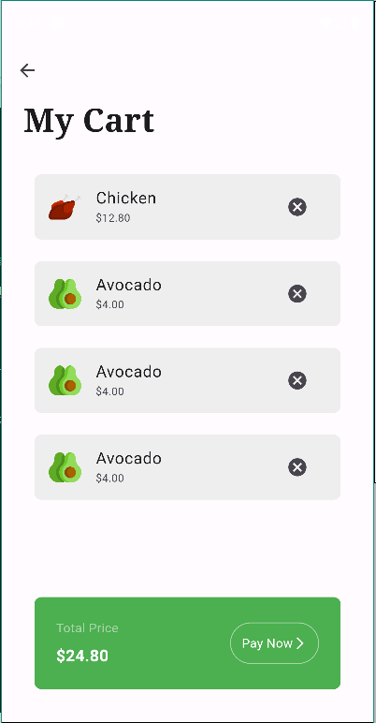

**This Flutter code defines a `CartPage` widget, representing the page where users can view and manage items in their cart. Here's a breakdown of its structure and functionality:**

**1. **Widget Structure**:**

- The `CartPage` widget is a stateless widget (`StatelessWidget`) that displays the content of the cart.

- It consists of a `Scaffold` widget, providing a basic layout structure for the screen.

**2. **App Bar**:**

- The app bar is configured with a transparent background and no elevation (`elevation: 0`).

- The icon color is set to grey (`Colors.grey[800]`).

**3. **Body Content**:**

**-** The body of the `CartPage` consists of a `Consumer` widget listening to changes in the `CartModel`.

- It starts with a title "My Cart" displayed using `GoogleFonts.notoSerif`.

- The list of cart items is displayed in a `ListView.builder`, where each item is represented by a `ListTile`.

- Each `ListTile` contains the item's name, price, and an icon button to remove the item from the cart.

**4. **Total Price and Pay Now**:**

- Below the list of items, the total price of all items in the cart is displayed along with a "Pay Now" button.

- The total price is calculated using the `calculateTotal()` method of the `CartModel`.

- The "Pay Now" button is styled with a green background color and bordered container, containing text and an arrow icon.

**Overall, this `CartPage` provides users with a clear view of items in their cart, along with the total price and an option to proceed with payment.**